7-A: Monitoring HTTP/HTTPS Messages Using Wireshark

Aim: To capture and analyze HTTP/HTTPS messages exchanged between a browser and the website https://www.sathyabama.ac.in using Wireshark.

Procedure & Observation
- Open Wireshark on your system.
- Select the active network interface (the one connected to the internet).
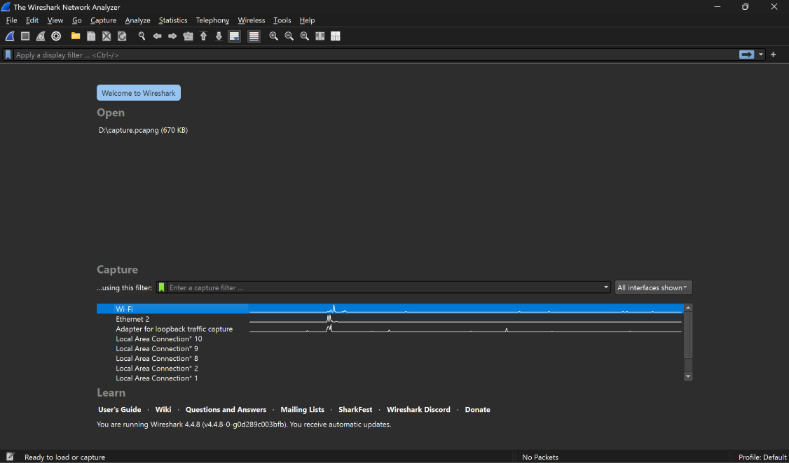
- Start packet capture on this interface.

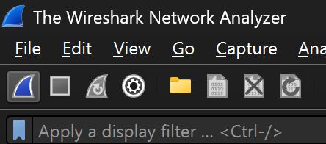
- Open the browser and go to https://www.sathyabama.ac.in. Wait until the website fully loads.

- Stop the capture in Wireshark
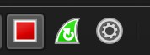
- Apply the filter tls in the display filter bar to view only HTTPS/TLS packets.
tls.handshake → shows only the handshake messages.
tls.handshake.type  packets. | == | 1 | → | only | Client | Hello
tls.handshake.type  packets. | == | 2 | → | only | Server | Hello

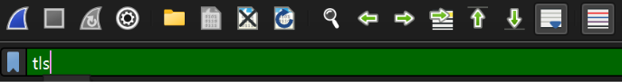
- Observe the handshake and encrypted traffic:
Around Packet 1217 → TLSv1.2 Application Data begins.
Packets 1218, 1220, 1221, 1222, 1223 → contain Encrypted Application Data.
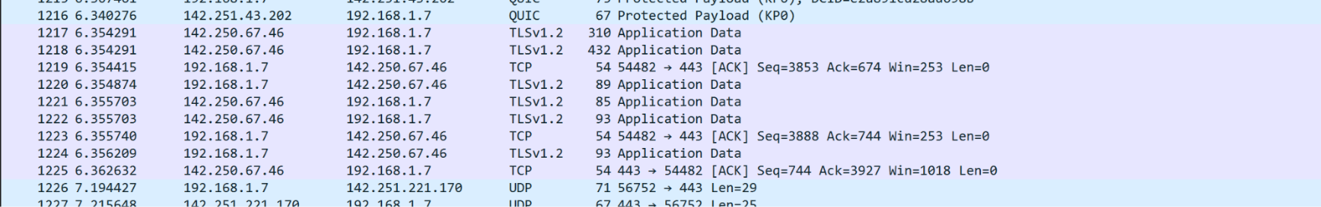
Packet 1219 → shows a TCP ACK confirming proper delivery.

9.Note that after the handshake, all data is encrypted.

Result: The HTTPS communication with www.sathyabama.ac.in was successfully captured.
TLS handshake and encrypted packets were clearly visible in packets 1217–1223, proving that HTTPS traffic is secure. Experiment completed successfully.

Ex. 7.b
Use Wireshark to determine which port had the highest traffic while browsing YouTube.
Aim: To capture and analyse network traffic using Wireshark and determine
the port number that carries the highest amount of traffic during YouTube browsing.
Requirements:
- Wireshark installed on the system
- Active internet connection
- Access to YouTube
Algorithm:
- Start Wireshark and select the correct network interface (Wi-Fi or Ethernet).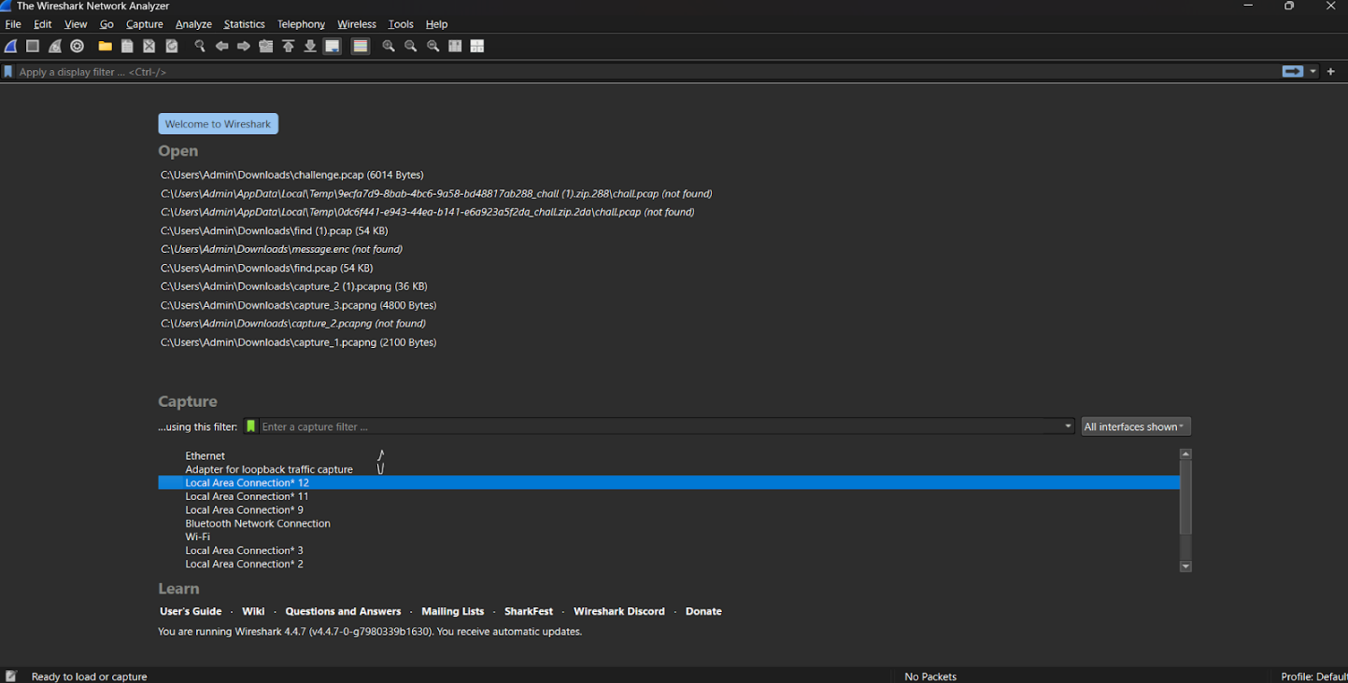
- Begin packet capture by clicking the "Start Capturing" button.
- Open YouTube in a web browser and play videos for a few minutes to generate sufficient traffic.
- After browsing, stop the capture in Wireshark.
- Apply filters if needed:
tcp.port == 443 (for HTTPS traffic)
udp.port == 443 (for QUIC traffic)
- Go to Statistics → endpoints and Sort the results by the Bytes column to find which port handled the maximum amount of traffic. Note down the port number with the highest traffic.
- Look at the Bytes column to check which port shows the highest data transfer.
Identify the port number and note it down.
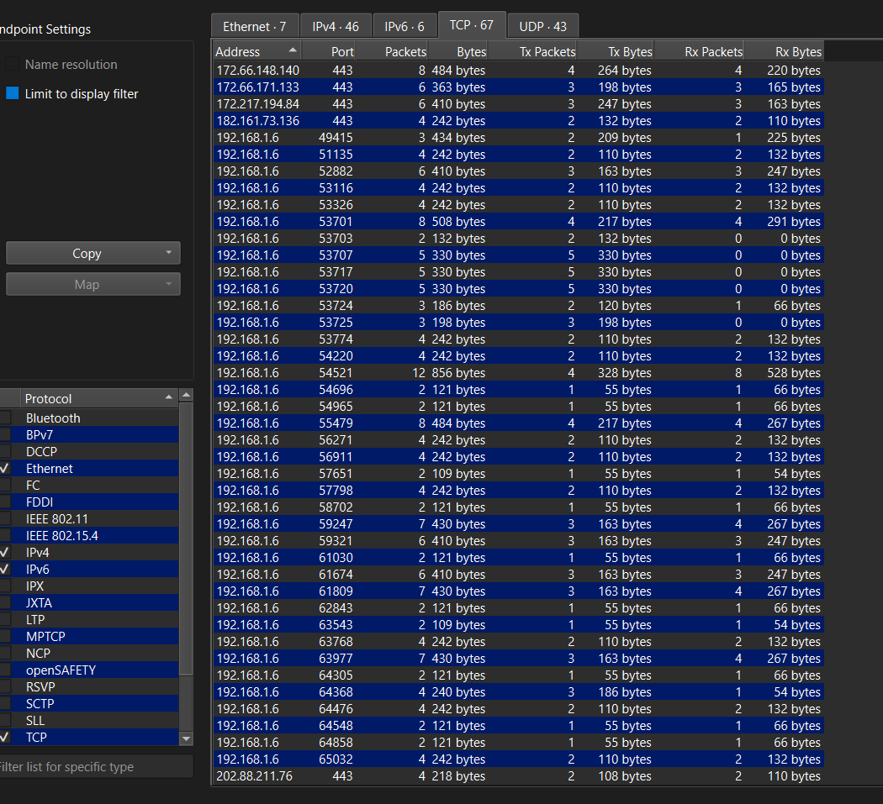
Output:
The majority of packets while browsing YouTube are sent over Port 443.
The highest traffic while browsing YouTube occurred on Port 443 (used for HTTPS and QUIC).
Thus, Port 443 is the main port responsible for carrying YouTube streaming traffic.
Result: Thus finding out the highest traffic port while browsing youtube using
wireshark is successfully executed

